Indian Muslim Trust Report
2024-2025

Medical Support and Aid to Critically Ill (through our delivery partner, Paincaretrust.com)

Location 2024/2025 | Types of Illness | Amount Indian Rs. | Approx. Number of Beneficiaries
Bhiwandi, Thane | Critical | 3,00,000
Totals |  |  | 100 beneficiaries
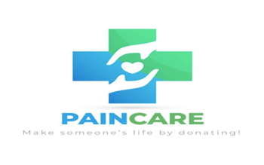
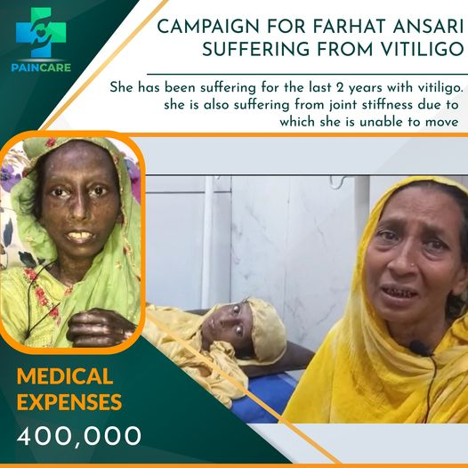
https://paincaretrust.com/
Delivery Partner
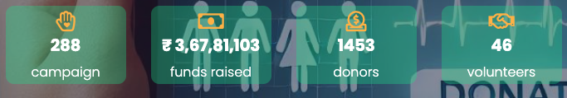
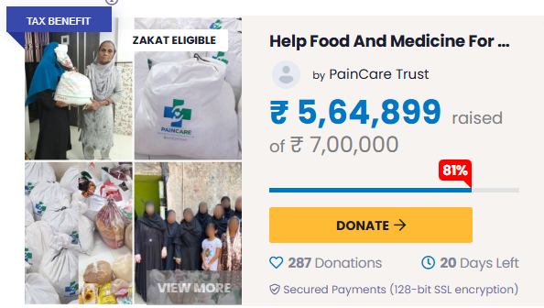
https://www.instagram.com/paincare_trust/
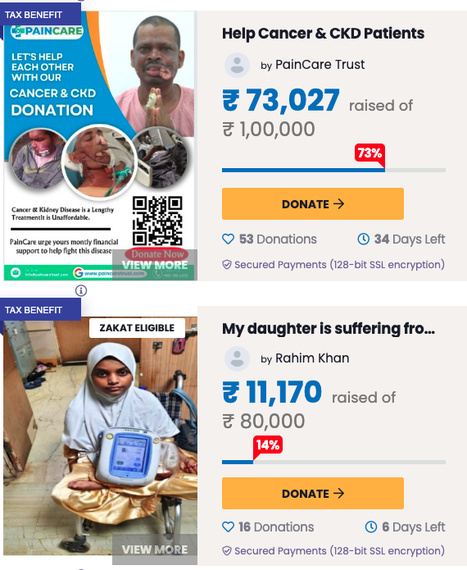
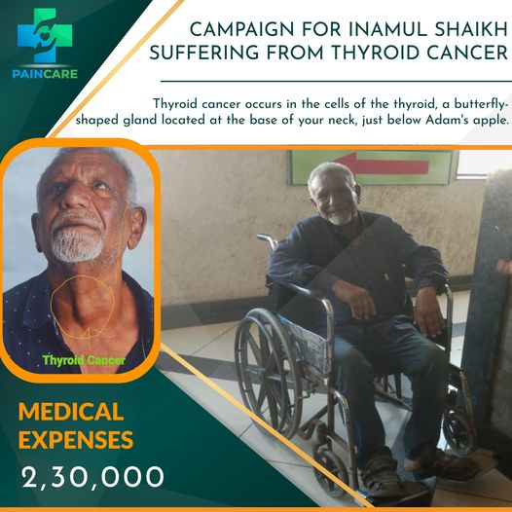

- Educational Sponsorship for deprived pupils and groups

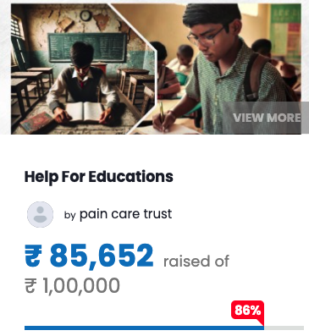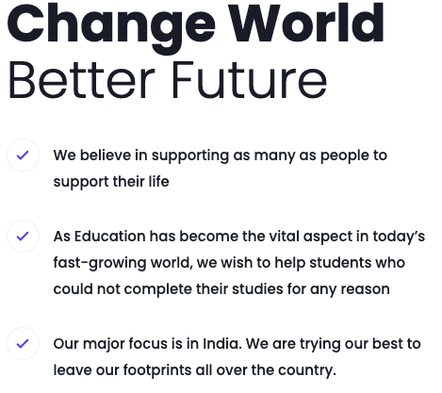

Food Relief and Ration Distribution to Elderly and destitute (through our delivery partners in India)

Location 2024/2025 | Food Aid | Amount Indian Rs. | Approx. Number of Beneficiaries
Bhiwandi, Thane | 200 | 3,00,000.00
Delhi, UP | 25 | 50,000
Totals |  |  | 225 Families  x3.3 =750 beneficiaries

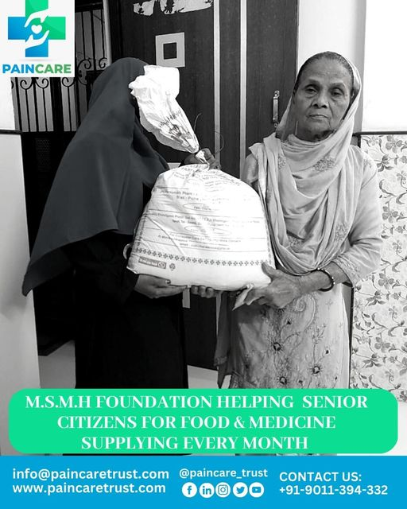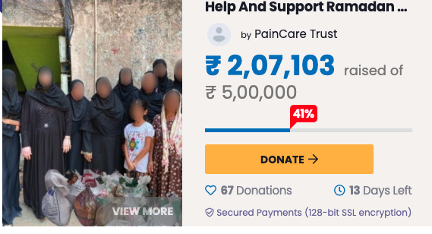

Muslim women educational empowerment Sponsorship (through good offices of Indian Trust)
Location 2024/2025 | Education Aid | Amount Rs. | Approx. Number of Beneficiaries
Bhiwandi, Thane | 20 | 100,000.00
Partapgrah, UP | 150 | 27,50,000
Totals |  |  | 170  beneficiaries

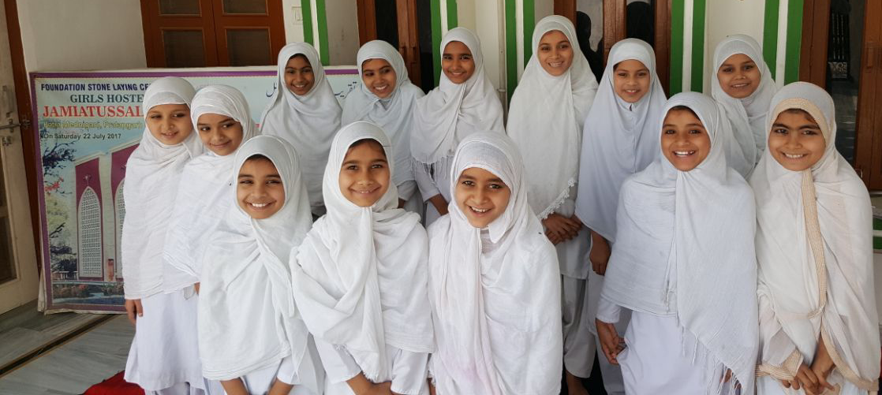
Pupils of a Girl’s School in North India, UP

Muslim High Professional development and empowerment Sponsorship
Location 2024/2025 | Education Aid | Amount Rs. | Approx. Number of Beneficiaries
Bhiwandi, Thane | 4 MBBS | 600,000.00
Delhi, India | 1 Journalism | 2,50,000
Totals |  | High Caliber | 5 High impact  beneficiaries

- Empowerment through Zakat systems promotion

Individual vs Institutional Zakat, Scholars Call for Hybrid, Trust-Based Models at New Delhi Seminar
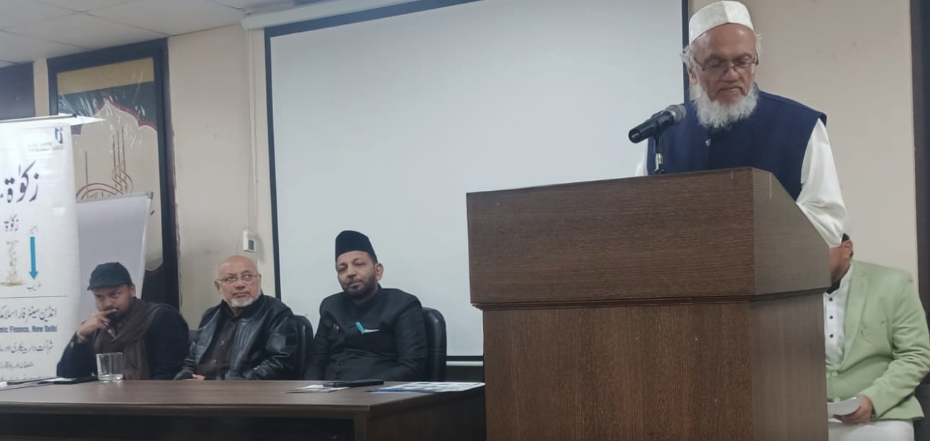
https://indiatomorrow.net/2026/01/07/individual-vs-institutional-zakat-scholars-call-for-hybrid-trust-based-models-at-new-delhi-seminar/

7. Economic Empowerment through Microcredit Institutions
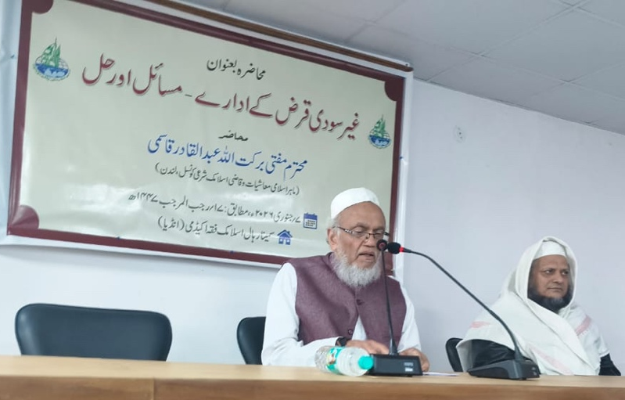

AICMEU with JANSEVA MUMBAI
In Partnership of IMRC U K
TO
EMPOWER FINANCIALLY VOLNURABLE MINORITY 90 GROUPS
USING INTEREST FREE MICRO FINANCE MECHANISM
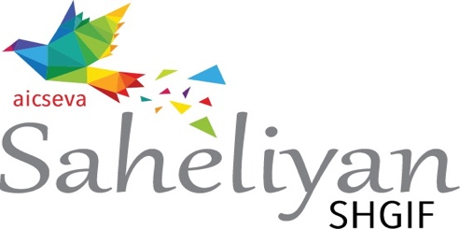
AT
12 STATES OF INDIA
Regd. And Head Office Address:
AICMEU, VAZIR BUILDING,1st FLOOR, 179 I.R ROAD, MUMBAI -400 003 (INDIA)
Phones: +91-22 2347 6497 / 91-22 2347 8329 / 91 98202 55784
E-mail ID’s: aicmeus@yahoo.com / janseva@janseva.in / drrahmat12@gmail.com
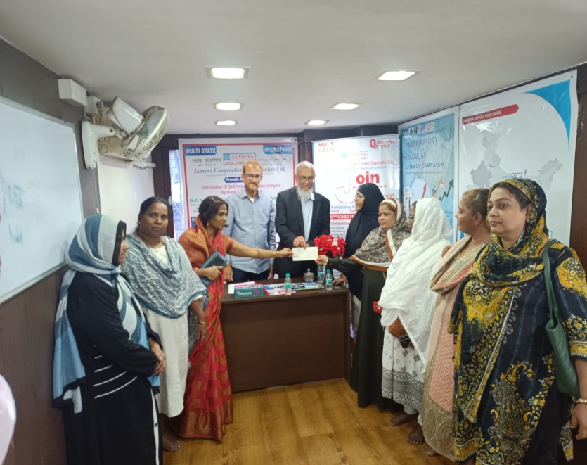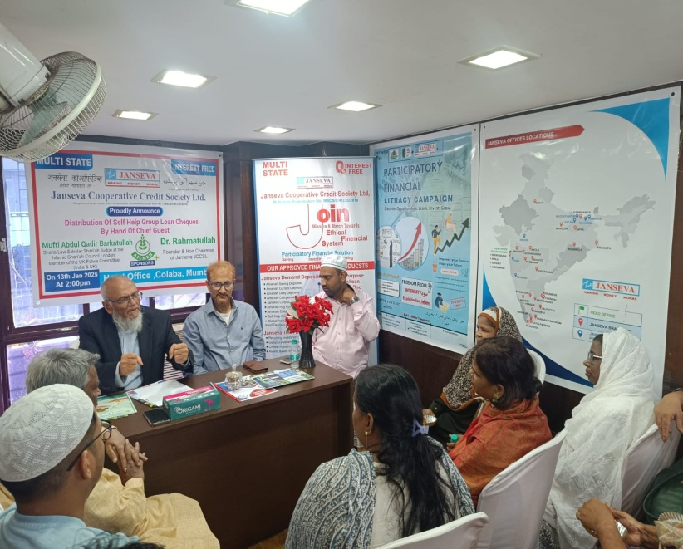

- Health Insurance Card distribution to Imams and teachers by Mufti Barkatulla
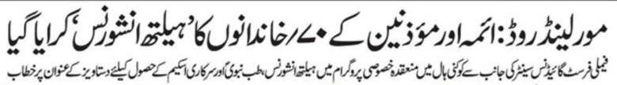
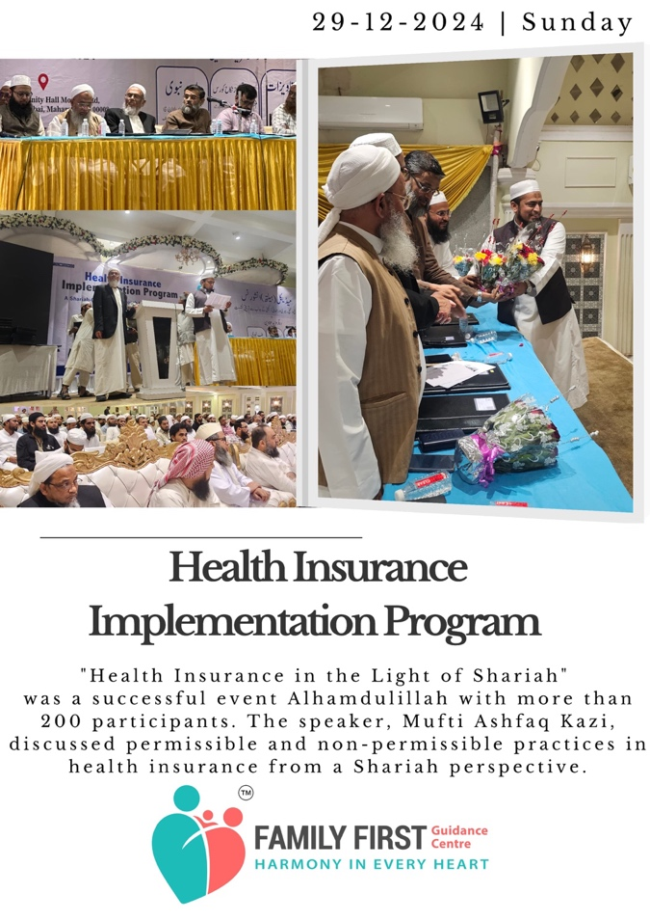
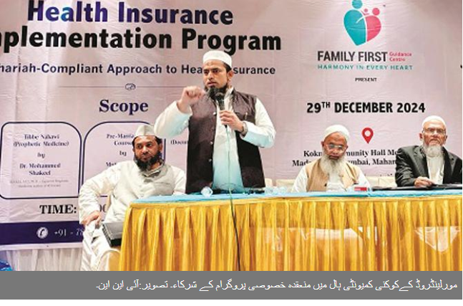
70 Families Health insurance distributed – during 2024-2025
https://www.facebook.com/familyfirstguidancecentre/photos

9. Family First Guidance and Support


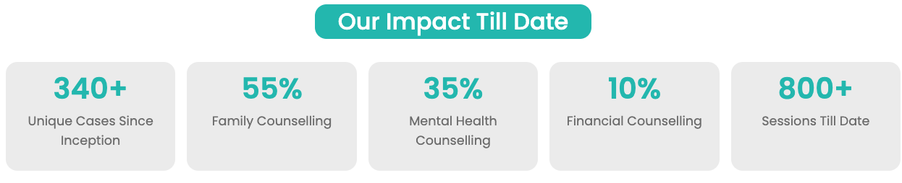
https://www.facebook.com/familyfirstguidancecentre/
https://www.instagram.com/familyfirstguidance/

10. Saksham - Empowering Muslim NGOs
Saksham is a Sanskrit-origin term meaning "capable," "competent," or "powerful,"


Organization Management | Project Management
Operations | Project Identification
Due Diligence | Project Planning
Risk Management | Project Execution
Community Engagement | Project Monitoring
Volunteer Management | Project Reporting
Legal & Compliance | Branding & Marketing
 | Events & workshops

https://www.gobizlab.com/saksham

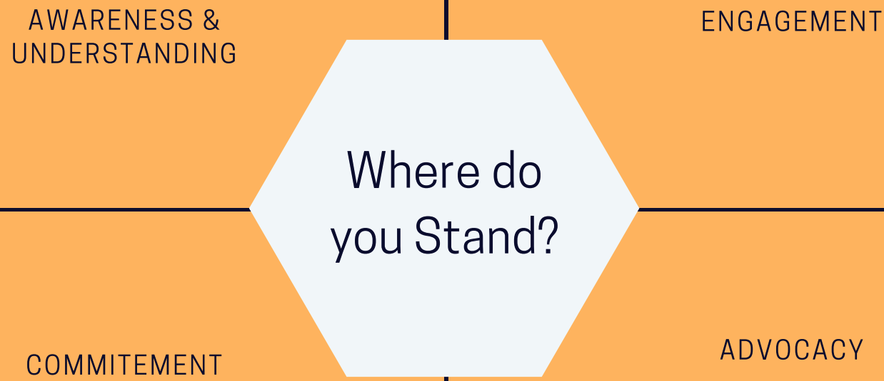

Training Organized for NGOs 2023-2024:
Introduction to Project Management Principles, & Practices for Academic World

Vitamin D - The Game Changer for COVID 19

Accessibility to CSR Funds for NGOs

Digital Fundraising for NGOs

Introduction to Project Management Principles, & Practices for Academic World

Vitamin D - The Game Changer for COVID 19

Accessibility to CSR Funds for NGOs

Digital Fundraising for NGOs

Legal & Compliance Management for NGOs

Finance Management For NGOs

Project Proposal Writing For NGOs

NGOs - Transforming the Future of India

Legal & Compliance Management for NGOs

Finance Management For NGOs

Project Proposal Writing For NGOs

NGOs - Transforming the Future of India

Business & Career Startup Workshop Ep 14 By Aslam Khan

PROMO - BUSINESS & CAREER STARTUP - iPlus TV

Business & Career Startup Workshop Ep 01 By Aslam

PROMO - BUSINESS & CAREER STARTUP - iPlus TV

Business & Career Startup Workshop Ep 01 By Aslam Khan

Business & Career Startup Workshop Ep 04 By Aslam Khan

(end of Report)

